Print Email Facebook Twitter More

Anzac Day 2015: Up to 15,000 'forgotten' Indian soldiers fought alongside Anzacs
By South Asia correspondent Stephanie March
Updated 25 Apr 2015, 6:34am

- 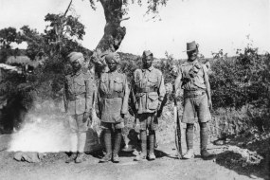Up to 15,000 Indians fought with allied troops at Gallipoli, but their contribution remains relatively unknown and unrecognised in Australia and their homeland, research has found.
"The average Indian is almost ignorant about Gallipoli as a campaign in World War I," retired Indian Air Force wing commander Rana Chhina said.
Historians believe almost 1,400 Indians died at Gallipoli and up to 3,500 were wounded.
Unlike many of the Australian troops, all the Indians who fought were professional soldiers.
"We had an Indian infantry brigade, the 29th Indian Infantry Brigade. We had a mountain artillery brigade and, of course, the mule transport," Mr Chhina said.
The Mule Corps comprised of 650 men and more than 1,000 mules to transport supplies to troops on the peninsula where motor transport was impossible.
Historians say the Mule Corps established themselves in an area known as Mule Gully, which came under constant sniper and machine gun fire during the day.
As a result, most transport took place at night.
"The Mule Corps were the unsung heroes of Gallipoli. If it hadn't been for them, the Anzacs and the rest wouldn't have been able to hold on in the manner that they did," Mr Chhina said.
PHOTO: Australian and Indian troops pose for a photograph at Gallipoli. (Supplied) 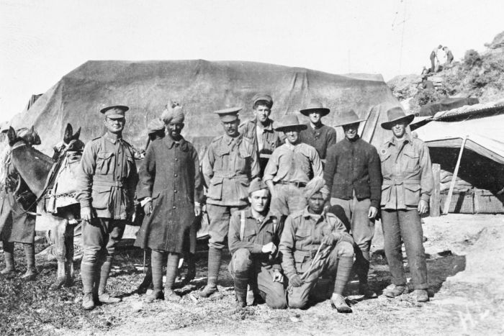

Indians and Australians were friends on the battlefield
Photographs and sketches from the time show Indian and Australian soldiers spending time together — sometimes sharing food rations.
"You would find Anzacs coming and sharing the Indian soldiers' rations because their roti and daal was far more palatable than the salted bully beef and biscuits," Mr Chhina said.
"The relationship between the Indians and the Australians and New Zealanders was actually very good, by all accounts.
"The Anzacs recognised that the Indians were professional soldiers. They developed a very healthy respect for them."
Mr Chhina said there was some evidence that friendships were formed on the battlefield between soldiers from the two countries.
"There are also various Australian and New Zealand accounts — in soldiers' diaries or in photographs that they've sent back home — where they refer to 'my Indian friend' or 'my Gurkha friend'," he said.

'The forgotten soldiers of history'
Many of the Indians who fought at Gallipoli were from the Punjab, but few records remain about their contribution to the war effort there.
When the British divided India in 1947 and the nation of Pakistan was created, millions of people — including many Punjabis — fled in different directions across the newly-created border.
"It was the largest mass migration in human history — almost all of their letters and other belongings and possessions were destroyed," Mr Chhina said.
"The same happened at an official level. A lot of our World War I records were destroyed during the trauma of partition."
Mr Chhina said the only recognition of some of the 15,000 who fought — or the approximately 1,500 Indian soldiers who died at Gallipoli — is a small plaque at a hospital in Ferozepur in the country's north.
"I am afraid they are literally the forgotten soldiers of history," he said.
One man who has not forgotten the contribution Indian soldiers made at Gallipoli is Perth doctor Tajinderpal Singh.
His great-grandfather, Nanak Singh, served as part of the 1/69 Punjabi regiment at Gallipoli.
"My great-grandfather said the battle of Gallipoli was a very bloody battle and it was very traumatic," Mr Singh said.
"He said as they landed on the beaches there were bodies everywhere.
"It was very unfortunate in that there were many Sikh bodies there and they were friends that he knew — other soldiers that they knew — and the only way to get off the beach was to walk over these bodies."
PHOTO: A sketch done by a soldier showing an Australian sharing lunch with an Indian in Gallipoli. (Supplied) 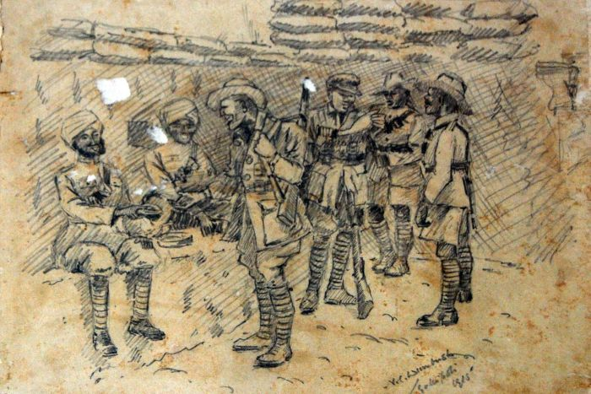

Perth marching band remembers Sikh soldiers at Gallipoli
Mr Singh said his great-grandfather said the conditions at Gallipoli were awful and would talk of the Turks as a "fearless race".
"He said there was one Turk hiding in the carcass of a cow and he was shooting many Sikhs. After a fierce battle with him and his comrades, the Sikhs overcame him," he said.
Nanak Singh survived the war and died in 1976, aged 102.
In 2006, his great-grandson created the Western Australian Sikh marching band as a way of honouring his relative's sacrifice.
"To have family that is involved in a battle which is so important to all Australians, it made us so proud. We said, 'We have to do something about it' and that is how the band came about," Mr Singh said.
"We said we need to honour the legacy of my great-grandfather but more importantly to honour the legacy of Sikhs in general that fought at Gallipoli and other battles at World War I."
The band is made up of 35 members of Perth's Sikh community — most of whom had never played an instrument before they joined.
"We thought this is great, to form a band, and to march at Anzac Day, to show we are Australians just like everyone else is," Mr Singh said.
"It is an honour knowing my great-grandfather was there fighting with the Anzacs, and he was an ally of the Anzacs.
"I feel as proud as any other Australian would do about Anzac Day."

